# Executive Summary

BNP Paribas Cardif a forward-looking global personal insurance company improving their services by modern technology. We have been looking at how time and money can be saved by improving the methods of handling the insurance claims BNP Paribas Cardif receive.

The question we want to help BNP Paribas Cardif answering is:

“How can BNP Paribas Cardif predict whether a claim should be approved or not, based on already known features?”

Based on our analysis, Team Tyrell has selected a model based on Extreme Gradient Boosting-algorithm with Cross Validation. The model is very fast, has an accuracy of XX % and used as a tool will help accelerate the processing of insurance claims at BNP Paribas Cardif.

Our analysis shows which features are the most important in order to correctly predict the right category of insurance claim. This is valuable information for BNP Paribas Cardif, because it enables you collecting the correct and important features that ensures correct predictions.

[More $$$ and numbers (% better) needed]

# Most Important Features

In order to help BNP Paribas Cardif to understand what information is important to gather in order to accelerate their claim management, Team Tyrell has analysed the data and found the ten most important features accurately predict the category of a claim.

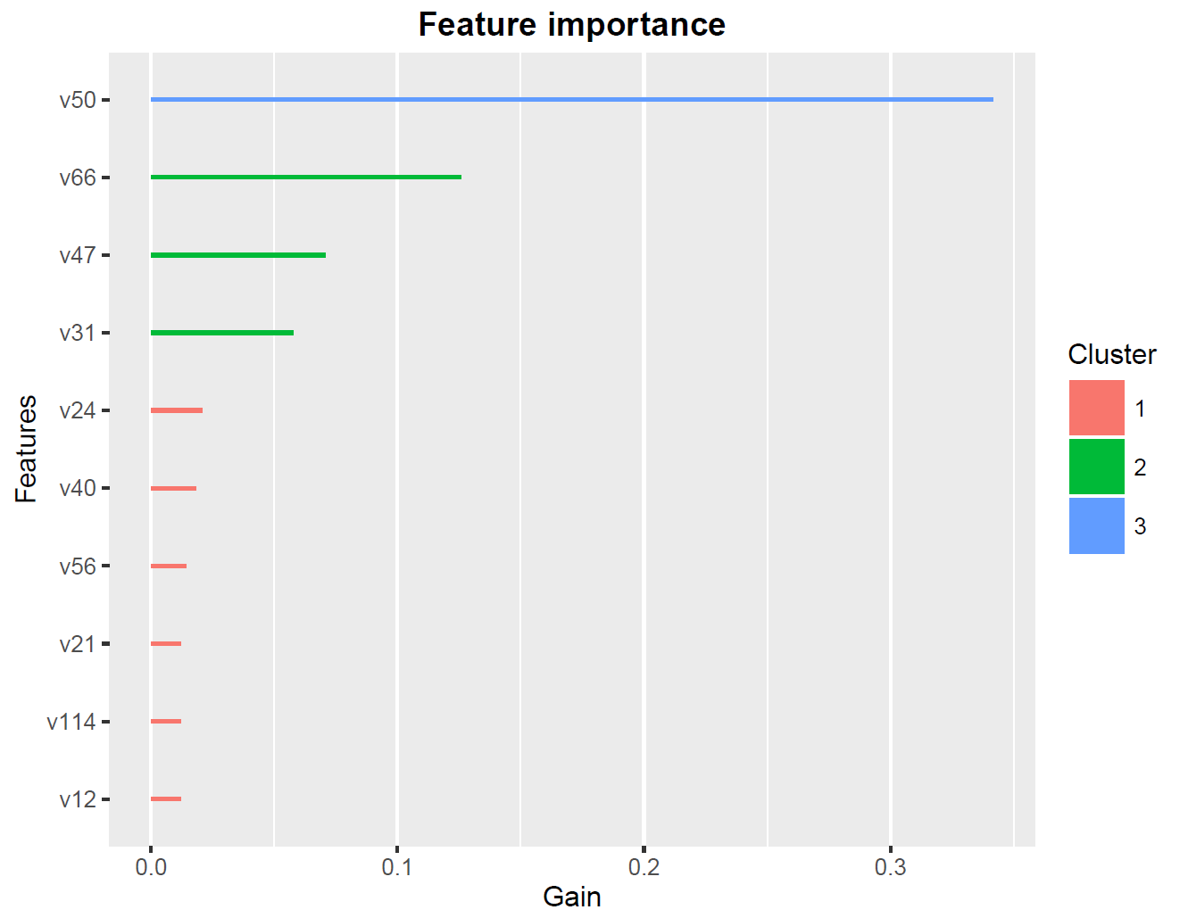

Figure 1: The ten most important features in predicting whether the claim should be accepted or it needs more information. Features is variable name, Gain is relative importance and Cluster categorise the features together. Cluster 3 is most important.

As we can see in Figure 1 the feature v50 is by far most important, and BNP Paribas Cardif should ensure that that column is, as long as possible, not a missing value and the information is gathered before running the model. The variables in cluster 2 (v66, v47 and v31) added together also majorly impact the outcome of our model.

Therefore as a minimum the claim management should prioritise gathering the cluster 3 and cluster 2 information as early and as accurately as possible.